VCE Ancient History Melbourne Excursion
Before your excursion  - Book your tour at the Hellenic Museum on (03) 8615 9016 or www.hellenic.org.au  - Book your tour at the National Gallery of Victoria on (03) 8620 2340 or www.ngv.vic.gov.au  From mid-2020, you will also be able to see Greek, Near Eastern and Egyptian objects at the Ian Potter Museum of Art – (03) 8344 5148 or www.art-museum.unimelb.edu.au/  On the day  Catch a train from  ____________at _________  arriving at Flagstaff Station at  ____________.  (If travelling from regional Victoria or some parts of Melbourne, you will need to change trains at Southern Cross Station.)  The Hellenic Museum is opposite Flagstaff Station, at 280 William Street.  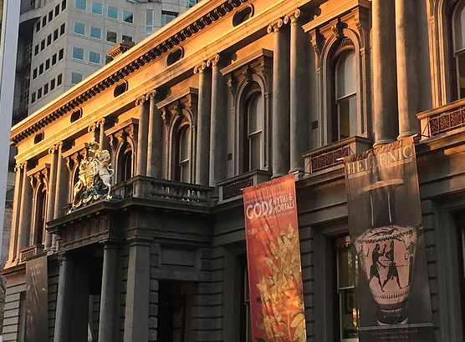  Your tour will begin at  ______________ | Hellenic Museum  The Hellenic Museum displays a collection of objects from ancient Greece that illustrate several key themes in the Ancient History study design.  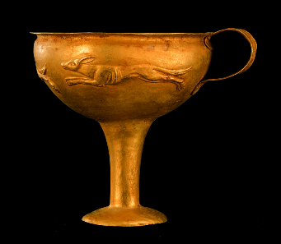  Bronze Age cultures  Minoan and Mycenaean objects in the collection illustrate the wealth and sophistication of Greece’s Bronze Age cultures. This can be seen particularly in a finely crafted Mycenaean gold necklace and cup. Though Mycenaean and Minoan society catastrophically collapsed in the 11th century BCE, cultural memories of these times were partly preserved in the world of Greek myth during the ensuing Dark Age.  The development of ancient Greece  Two geometric vases from the 8th and 7th centuries BCE illustrate the period when Greek culture was developing out of the Dark Age. The decoration of these vases (referred to as ‘geometric’) is relatively simple, consisting of geometric patterns and basic figures.  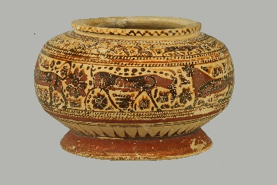  These vases can be contrasted with later vases, with more detailed and life-like figures, reflecting the further development of Greek society and changing styles.  The collection includes vases from Attica, Corinth and South Italy. Each of these areas has its own distinct style of vase decoration. This illustrates the independence and cultural variation of the ancient Greek city-states.  The Athenian economy  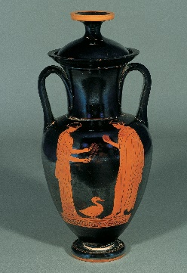  Athens relied heavily on imports to feed its population. Athens had to sell goods in return, to pay for the imports. One of Athens’ most visible exports was pottery – Attic pottery has been found all around the Mediterranean, especially in Italy. As an example of this, the Hellenic Museum’s collection includes a fine Nolan amphora, a design regularly exported to Italy.  A major boost to Athens’ economy came from the discovery of silver ore deposits in 483 BCE. Several Athenian silver coins in the collection attest to this source of wealth.  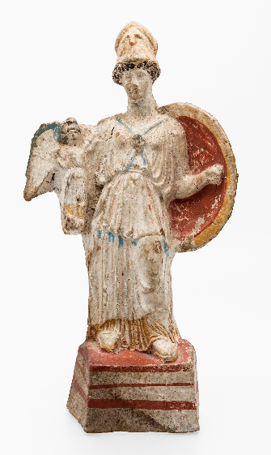  In the later 5th century, tribute from members of the Athenian Empire became another important source of revenue for Athens. This wealth facilitated a building program instituted by the statesman Pericles, which included the Parthenon. Inside the Parthenon, stood a giant gold and ivory statue of the goddess Athena. A statuette at the Hellenic Museum was modelled on that statue and gives us a chance to engage with the Periclean building program.  The importance of religion  The prevalence and significance of religion in the daily lives of the ancient Greeks can be seen in the wide variety of objects featuring depictions of the gods. This includes crockery, a mirror, jewellery and coins, as well as stand-alone statuettes.  Images © Benaki Museum, Athens

Events at the Hellenic Museum
The Hellenic Museum offers a variety of events through the year relating to Greek culture, both ancient and modern. These include a summer school each January, which explores different aspects of ancient history and is ideal for teachers and advanced students.
Getting from the Hellenic Museum to the National Gallery of Victoria  Return to Flagstaff Station and catch a train to Flinders Street Station  departing at _____________  arriving at _____________  (Note: the last train to Flinders Street Station leaves Flagstaff at 12.49 pm – if travelling later than this, you will need to go by tram.)  On the train trip, you will pass by the Immigration Museum – details of this building were modelled on the Erechtheion, one of the 5th century BCE buildings on the Athenian Acropolis.  Walk from Flinders Street Station to the NGV, at 180 St Kilda Road.  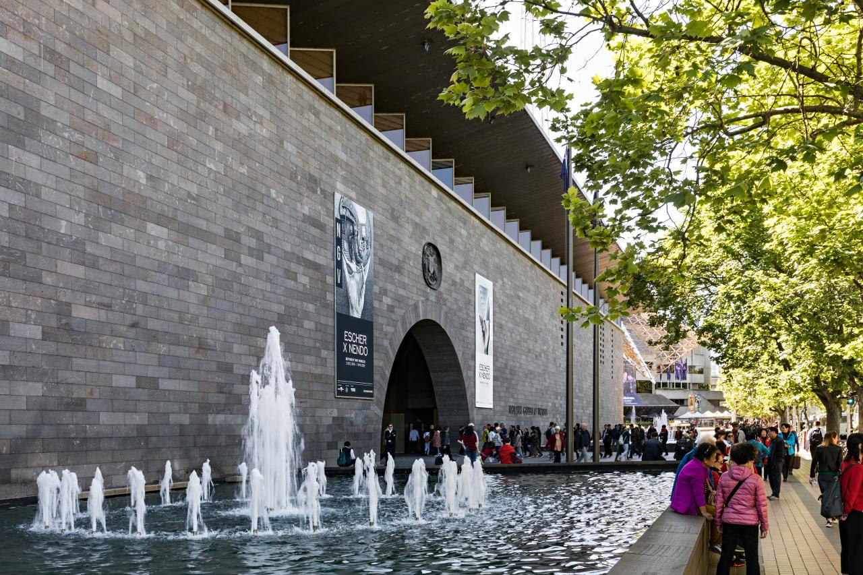  Your tour will begin at  ______________ | National Gallery of Victoria  The NGV’s collection includes objects from Egypt, Greece and Rome that relate to aspects of the Ancient History study design.  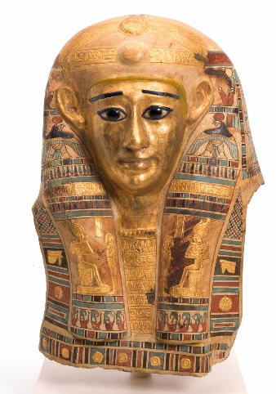  Care for the dead in ancient Egypt  Much of the Egyptian collection consists of objects associated with the dead. This includes objects associated with the bodies of the dead, such as a coffin, funerary mask, canopic jar and canopic box. The rich and detailed decoration of some of these objects illustrate the amount of money that the Egyptians were willing to spend to ensure a good afterlife and therefore the importance of this in Egyptian culture.  Several stone reliefs from tombs depict the deceased making offerings to gods. These can give us some insight into Egyptian society, as they mention aspects of the deceased’s life, such as their role as an official or members of their family.  In addition, the collection features models from tombs of things that the deceased was thought to need in the afterlife, including a boat and a female servant. The servant stands as a reminder of the hierarchical nature of Egyptian society.  Care for the dead in ancient Greece  Several Greek vases attest to care for the dead in ancient Greece. A geometric vase (c. 700 BCE) depicts a corpse surrounded by mourners. A white-ground Lekythos (460-455 BCE) portrays two women bringing offerings to a tomb. The vase itself is a type that was filled with oil and left at tombs as offerings for the dead. Two vases from Italy (one from Apulia and one from Campania) depict people bringing offerings to tombs. The important role of women in funeral rites can be seen from their presence on all these vases.  Warfare in ancient Greece  Several of the vases in the collection include depictions of mythological fights, including the Trojan War. The prevalence of scenes of fighting highlights the valorisation of war in ancient Greek culture. In the Apulian vase depicting a tomb, the deceased is portrayed with a breastplate hanging next to him, attesting to the importance of warfare in men’s actual lives.  Greeks and the Mediterranean  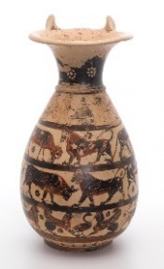  Vases of different styles illustrate the interaction of Greeks around the Mediterranean. A Corinthian vase from the 7th century BCE with bands of animals shows Near Eastern influence on the Greeks. A similar vase from Etruria is an imitation of the Corinthian style, attesting to the trade between Etruria and Greece.  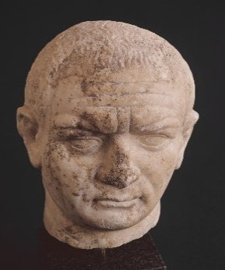  A variety of Greek vases from southern Italy show the spread of Greek settlers and Greek culture through colonisation.  Politics in ancient Rome  The imperial system which was the legacy of Augustus saw increasing power and prestige in the hands of the emperors. Their images appeared throughout the Roman Empire, on coins, on reliefs and as free-standing statues. The Gallery holds two examples of sculptures depicting Roman emperors – one of Vespasian (ruled 69-79 CE) and one of Septimius Severus (ruled 193-211 CE).

Activities at the NGV
The NGV offers many learning experiences for students, including talks, interactive activities and tours. These are focused on visiting exhibitions or elements of the permanent exhibition. Tours following themes related to a variety of school subjects are also available.

NGV Image Credits
Head covering of Padihorpasheraset, 1st century CE–2nd century CE
Lekythos (Attic white-ground ware), 460 BCE–450 BCE
Psykter amphora (Chalkidian black-figure ware), 540 BCE
Olpe (Corinthian black-figure ware), 630 BCE–620 BCE
Head of Vespasian, 50 CE–80 CE

